LED Interfacing with Arduino

**Aim**:

Design and implement different patterns using different colours of LEDs, vary on / off sequence and duration.

**Code for Blink**:

// This code, also known as blink, turns an LED on for one second and then off for one second, repeatedly.

// the setup function runs once when you press reset or power the board

// C++ code

void setup ()

{

// initialize digital pin LED_BUILTIN as an output

pinMode(LED_BUILTIN, OUTPUT);

}

// the loop function runs over and over again forever

void loop ()

{

// turn the LED on (HIGH is the voltage level)

digitalWrite(LED_BUILTIN, HIGH);

// wait for a second

delay(1000);

// turn the LED off by making the voltage LOW

digitalWrite(LED_BUILTIN, LOW);

// wait for a second

delay(1000);

}

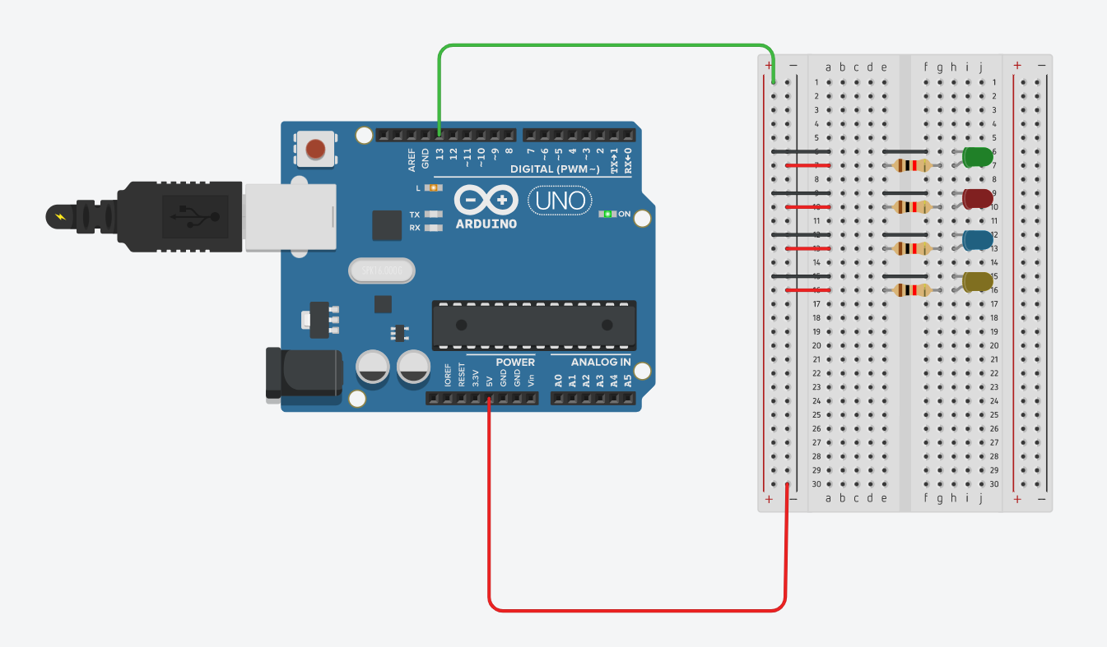**Connection diagram on Tinkercad:**

**Video of implementation:**

( video shared in drive folder - <https://drive.google.com/drive/folders/1Weo53Dhk3O7L1L3kURVPr2Z-ZvkWV797?usp=sharing> )

